Prepared by

Jaishree Kampoowale

Jaishreekampoowale31@gmail.com

Food Connect

To Supply Leftover Food To Poor



**ABSTRACT**

Despite significant advancements in food production, food waste remains a pressing global issue. Millions of people worldwide go hungry while tons of food are discarded daily. This project aims to address this disparity by developing a Salesforce-based platform called "Food Connect" to facilitate the redistribution of leftover food to those in need.

Food Connect will serve as a centralized hub connecting food donors (restaurants, grocery stores, catering services) with food recipients (shelters, food banks, community kitchens). The platform will leverage Salesforce's capabilities to:

* **Streamline Food Donation:** Donors can easily list excess food items, specifying quantities, expiration dates, and pickup locations.
* **Match Donors with Recipients:** Food Connect will utilize Salesforce's AI and machine learning capabilities to match donors with nearby recipients based on factors like location, food type, and recipient needs.
* **Manage Logistics:** The platform will facilitate communication between donors and recipients, coordinate pickups and deliveries, and track food distribution.
* **Track Food Impact:** Food Connect will collect data on food donations, recipients served, and meals provided to measure the platform's impact.

**Key Features:**

* **Donor Portal:** A user-friendly interface for donors to list excess food, manage donations, and track the impact of their contributions.
* **Recipient Portal:** A platform for recipients to register their organizations, request food, and track incoming donations.
* **Volunteer Management:** A module to recruit and manage volunteers for food collection and distribution.
* **Analytics and Reporting:** Tools to track key performance indicators, measure the platform's impact, and identify areas for improvement.
* **Mobile App:** A mobile application for both donors and recipients to enhance accessibility and convenience.

By leveraging Salesforce's powerful capabilities, Food Connect aims to create a sustainable and scalable solution for addressing food waste and ensuring that everyone has access to nutritious food.

**INDEX:**

* Introduction
* Object
* Tabs
* The lightening app
* Fields
* Flows
* Trigger
* Profiles
* Creation of users
* Public group
* Report types
* Reports
* Dashboards
* Sharing rules
* Homepage
* Conclusion

**INTRODUCTION**

In today's fast-paced world, food wastage has become a pressing global issue. While countless individuals struggle with food insecurity, surplus food often goes to waste. Food Connect is a Salesforce developer project designed to address this disparity by connecting businesses and individuals with excess food to those in need. By leveraging the power of technology, Food Connect aims to create a sustainable and efficient system that ensures leftover food is redistributed effectively, reducing waste and improving food security.

Food Connect utilizes a user-friendly platform built on the Salesforce platform. Businesses and individuals with surplus food can easily list their donations on the platform, specifying details such as quantity, type, and availability. Simultaneously, organizations and individuals in need can search for available food donations based on their location and requirements.

Once a match is found, Food Connect facilitates communication between the donor and recipient, coordinating pickup or delivery arrangements. The platform also provides tools for tracking donations, ensuring transparency and accountability in the food redistribution process.

Food Connect offers numerous benefits to both donors and recipients:

* **Reduced Food Waste:** By connecting surplus food with those in need, Food Connect helps to minimize food waste, reducing the environmental impact and conserving resources.
* **Improved Food Security:** Food Connect provides a reliable source of food for individuals and families facing food insecurity, helping to improve their overall well-being.
* **Strengthened Community Connections:** The platform fosters connections between businesses, organizations, and individuals, creating a sense of community and solidarity.
* **Enhanced Sustainability:** By promoting the redistribution of surplus food, Food Connect contributes to a more sustainable and equitable food system.

Food Connect is a innovative Salesforce developer project that has the potential to make a significant impact on food waste and food security. By leveraging technology and fostering collaboration, Food Connect aims to create a more sustainable and compassionate world where no one goes hungry.

**OBJECTS**

Salesforce objects are database tables that permit you to store data that is specific to an organization. What are the types of Salesforce objects

Salesforce objects are of two types:

1. **Standard Objects**: Standard objects are the kind of objects that are provided by salesforce.com such as users, contracts, reports, dashboards, etc.
2. **Custom Objects**: Custom objects are those objects that are created by users. They supply information that is unique and essential to their organization. They are the heart of any application and provide a structure for sharing data.

**Create Customer DetailsObject :**

To create an object:

From the setup page >> Click on Object Manager >> Click on Create >> Click on Custom Object.

Enter the label name >> Customer Details

Plural label name >> Customer Details

Enter Record Name Label and Format

Record Name >> Customer Name

Data Type >> Text

Click on Allow reports and Track Field History,

Allow search >> Save.

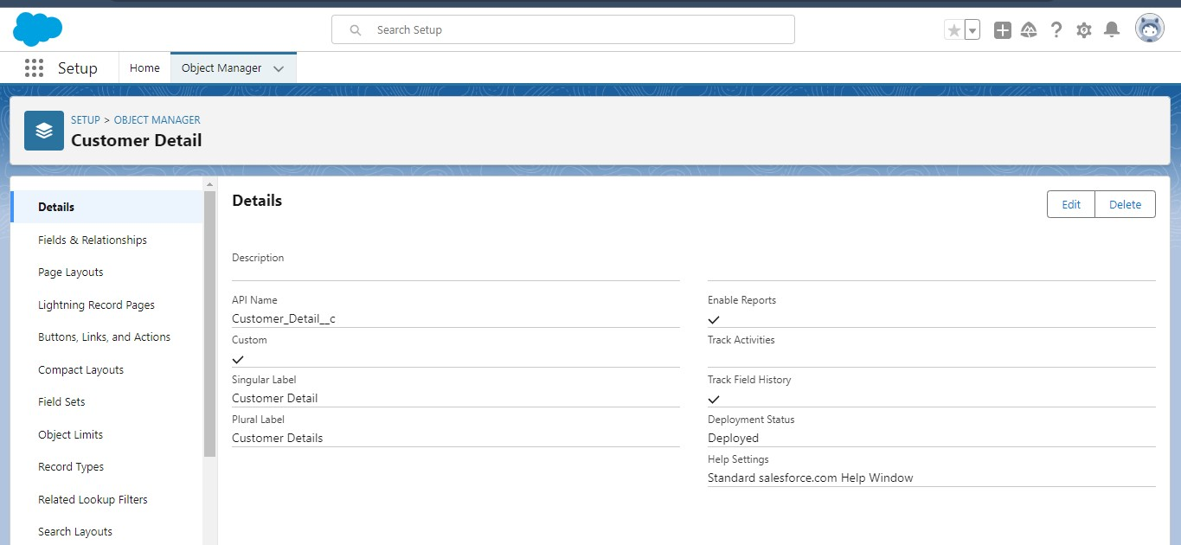

**Create Venue Object:**

To create an object:

From the setup page >> Click on Object Manager >> Click on Create >>Click on Custom Object.

Enter the label name >> Venue

Plural label name >> Venues

Enter Record Name Label and Format

Record Name >> Venue Name

Data Type >> Text

Click on Allow reports and Track Field History, Allow Activities.

Allow search >> Save.

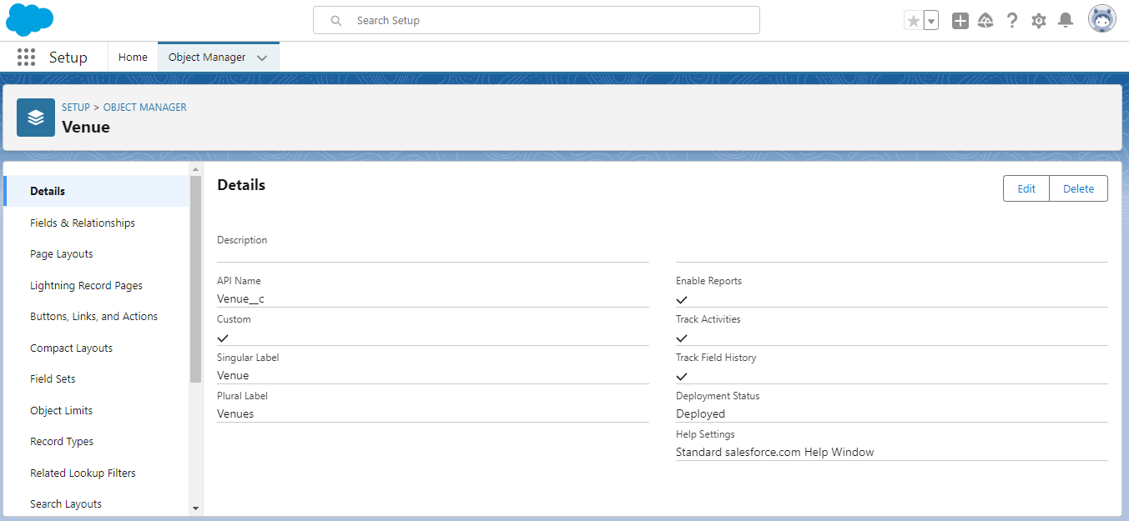

**Create Drop-Off Point Object**

To create an object:

From the setup page >> Click on Object Manager >> Click on Create >> Click on Custom Object.

Enter the label name >> Drop-Off Point

Plural label name>> Drop-Off Points

Enter Record Name Label and Format

Record Name >> Drop-Off point Name

Data Type >> Text

Click on Allow reports and Track Field History,Allow Activities

Allow search >> Save.

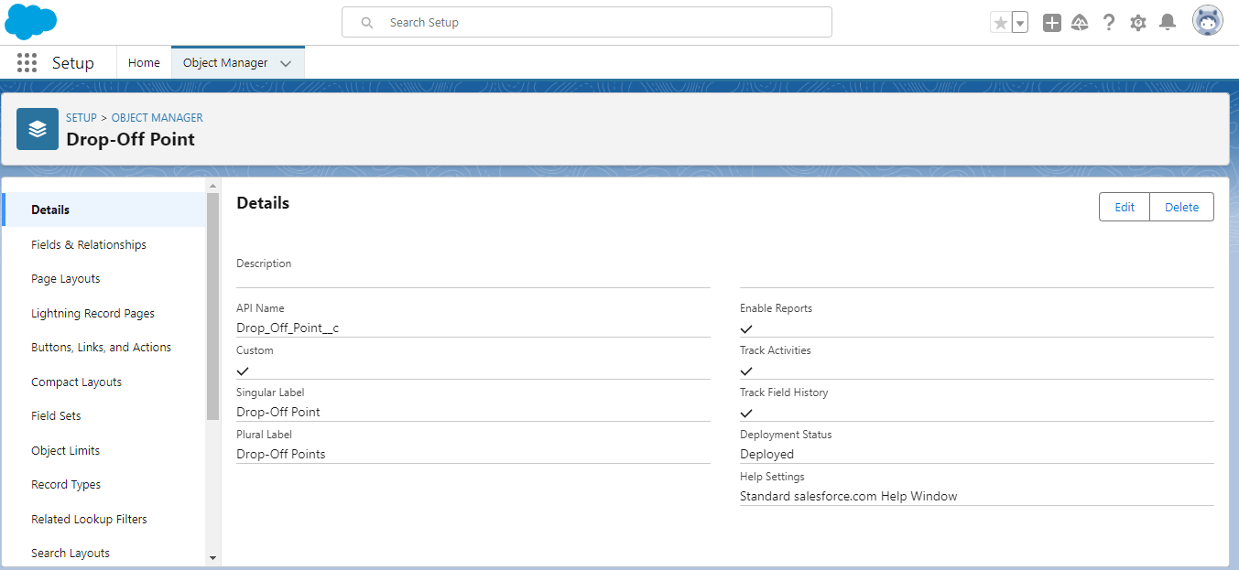

**Create Task Object**

To create an object:

From the setup page >> Click on Object Manager >> Click on Create >> Click on

Custom Object.

Enter the label name>> Task

Plural label name>> Tasks

Enter Record Name Label and Format

Record Name >> Task Name

Data Type >> Text

Click on Allow reports and Track Field History,Allow Activities

Allow search >> Save.

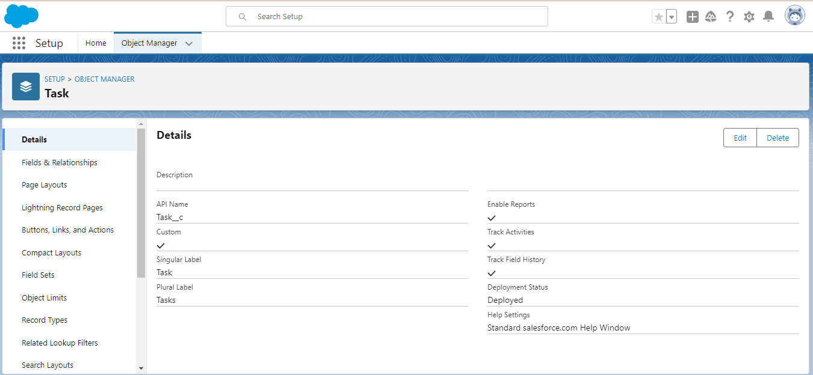

**Create Volunteer Object**

To create an object:

From the setup page >> Click on Object Manager>> Click on Create >> Click on Custom Object.

Enter the label name>> Volunteer

Plural label name>> Volunteers

Enter Record Name Label and Format

Record Name >> Volunteer Name

Data Type >> Text

Click on Allow reports and Track Field History, Allow Activities

Allow search >> Save.

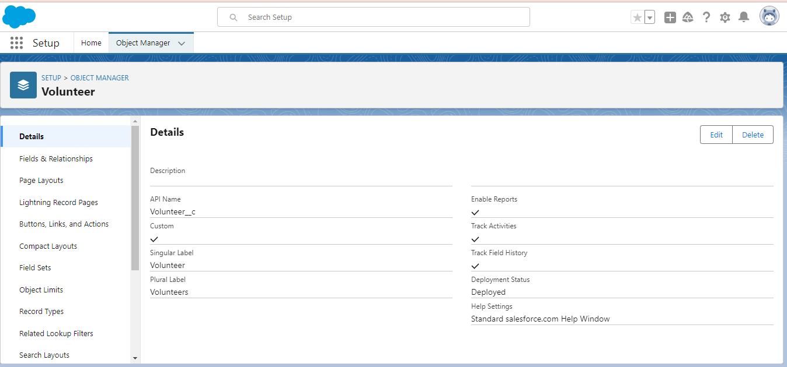

**Create Execution Details Object**

To create an object:

1. From the setup page >> Click on Object Manager >> Click on Create >> Click on Custom Object.
2. Enter the label name >> Execution Detail
3. Plural label name >> Execution Details
4. Enter Record Name Label and Format

* Record Name >> Execution Detail Name
* Data Type >> Text

1. Click on Allow reports and Track Field History, Allow Activities
2. Allow search >> Save.

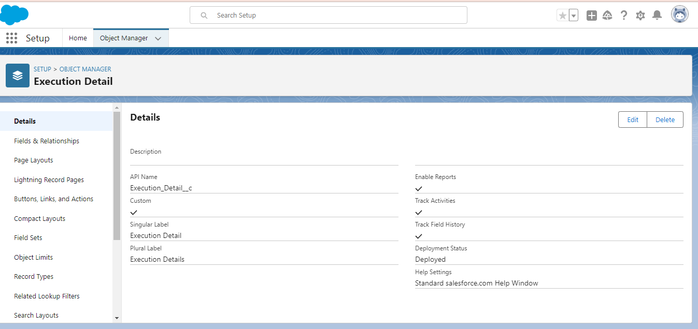

**TABS**

A tab is like a user interface that is used to build records for objects and to view the records in the objects.

**Creating a Custom Tab**

To create a Tab:(Venue)

1. Go to setup page >> type Tabs in Quick Find bar >> click on tabs >> New (under custom object tab)
2. Select Object(Venue) >> Select the tab style >> Next (Add to profiles page) keep it as default >> Next (Add to Custom App)  uncheck the include tab .
3. Make sure that the Append tab to users' existing personal customizations is checked.
4. Click save

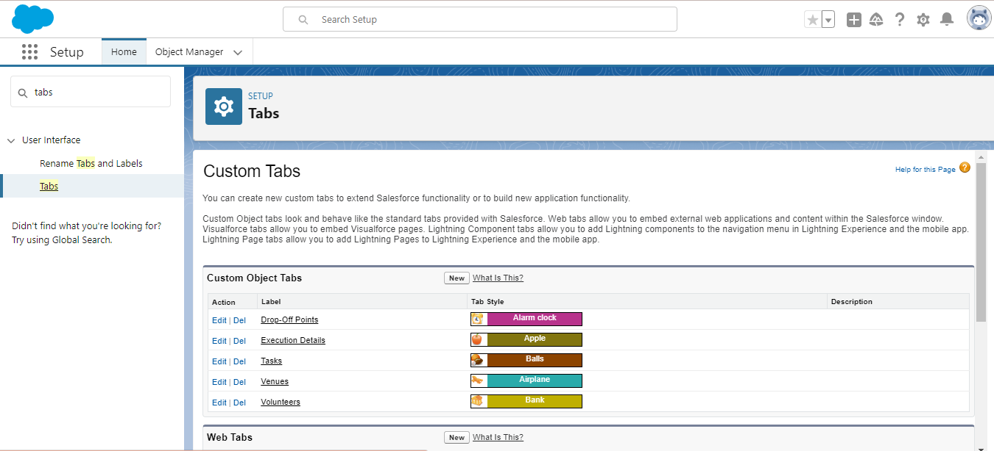

**Creating Remaining Tabs**

1. Now create the Tabs for the remaining Objects, they are “Drop-Off Point, Task, Volunteer, Execution Details”.
2. Follow the same steps as mentioned above

**THE LIGHTNING APP**

An app is a collection of items that work together to serve a particular function. In Lightning Experience, Lightning apps give your users access to sets of objects, tabs, and other items all in one convenient bundle in the navigation bar.

**Create a Lightning App**

**To create a lightning app page:**

1. Go to setup page >> search “app manager” in quick find >> select “app manager” >> click on New lightning App.
2. Fill the app name in app details and branding as follow  
   App Name : FoodConnect  
   Developer Name : This will auto populated  
   Image : optional (if you want to give any image you can otherwise not mandatory) Primary color hex value : keep this default.
3. Then click Next  >> (App option page)Set Navigation Style as Standard Navigation >> Next.
4. (Utility Items) keep it as default >> Next.
5. To Add Navigation Items:

Search for the item in the (Home, Venue, Drop-Off Point, Task, Volunteer, Execution Details, Reports) from the search bar and move it using the arrow button >> Next >> Next.

1. To Add User Profiles:

Search profiles (System administrator) in the search bar >> click on the arrow button >> save & finish.

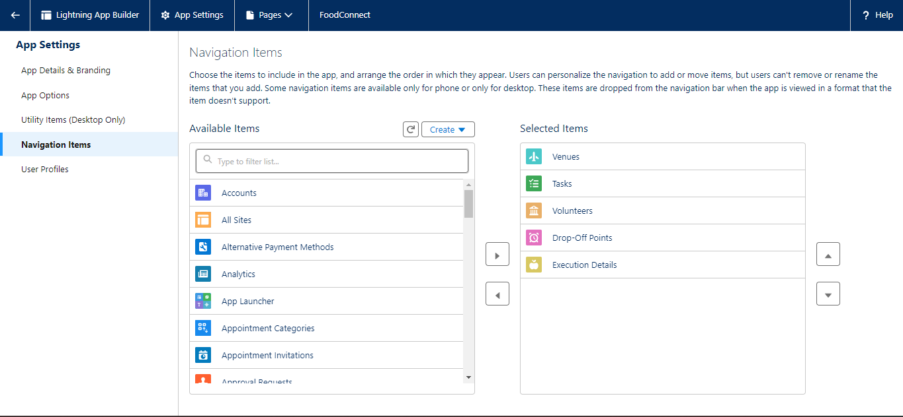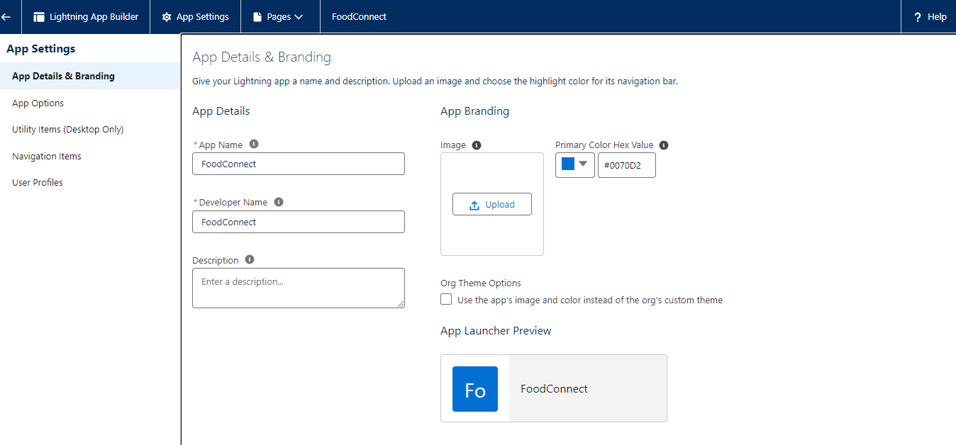

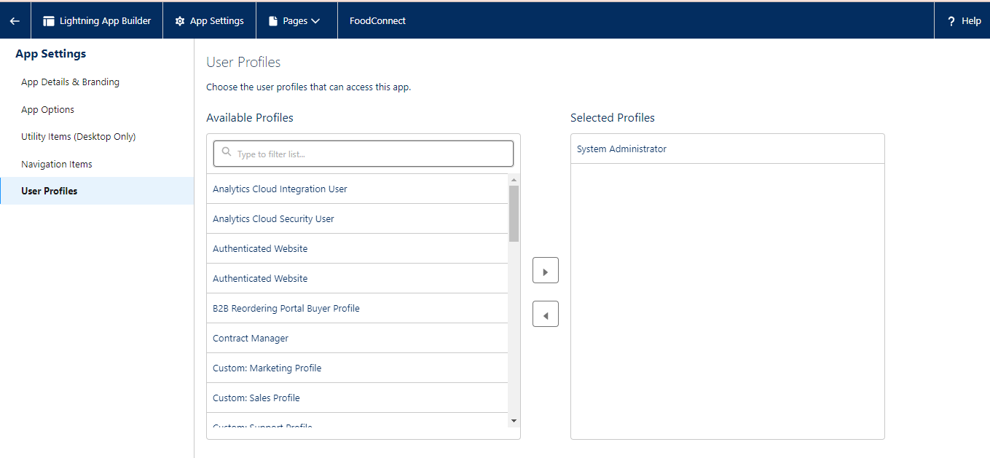

**FIELDS**

**Creation of Lookup Relationship Field on Volunteer Object :**

1. Go to setup >> click on Object Manager >> type object name(Volunteer) in the search  bar >> click on the object.
2. Now click on “Fields & Relationships” >> New
3. Select Master Detail relationship
4. Select the related object “Drop-Off point” and click next.
5. Field Name : Drop_Off_point
6. Field label : Auto generated
7. 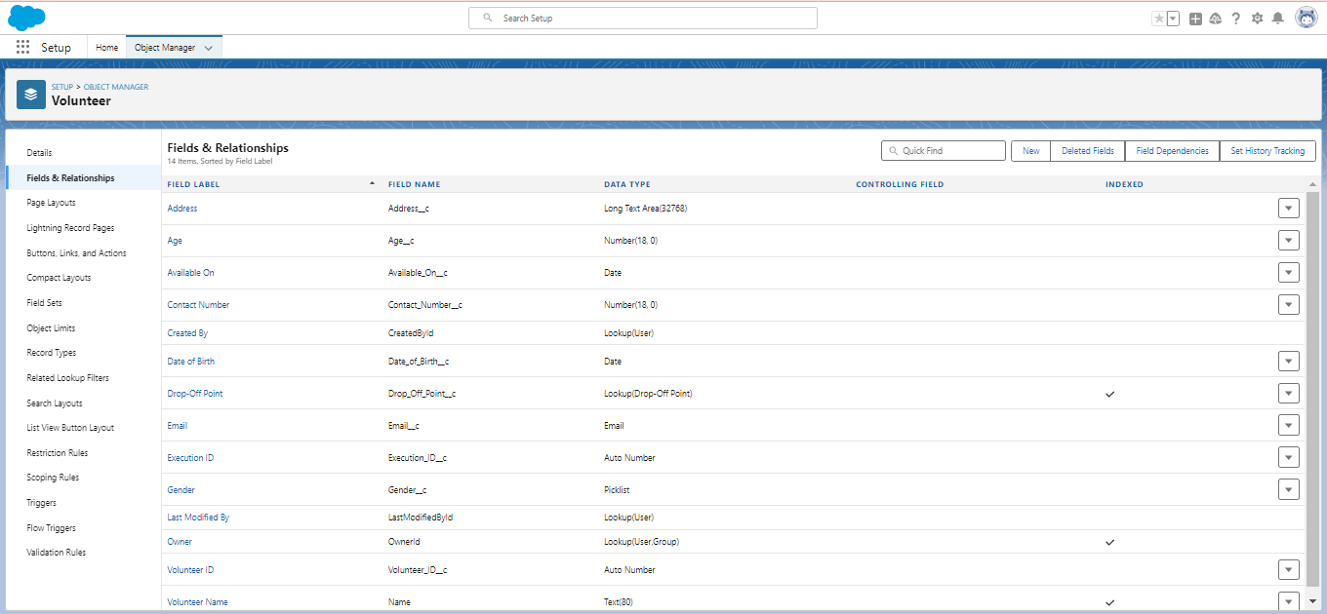Next >> Next >> Save.

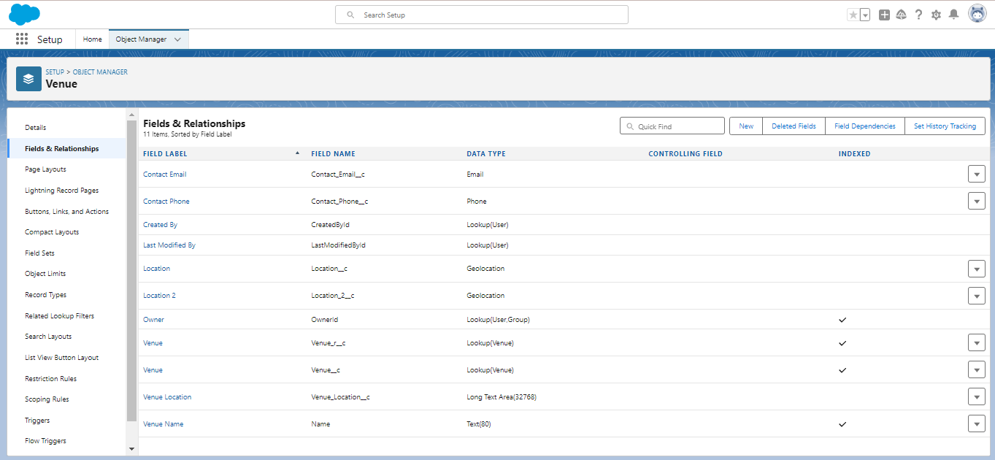

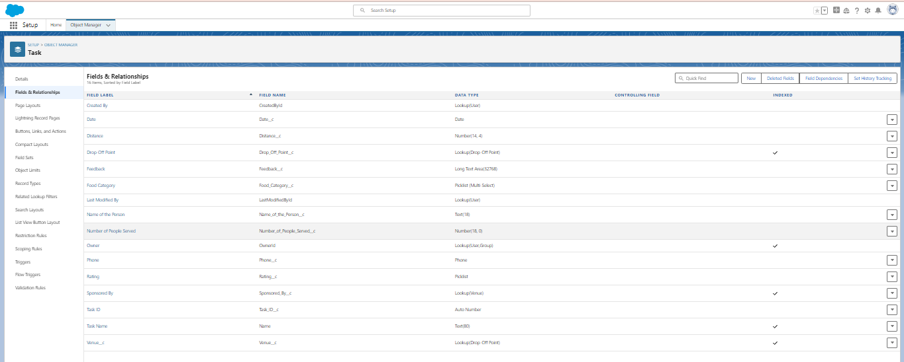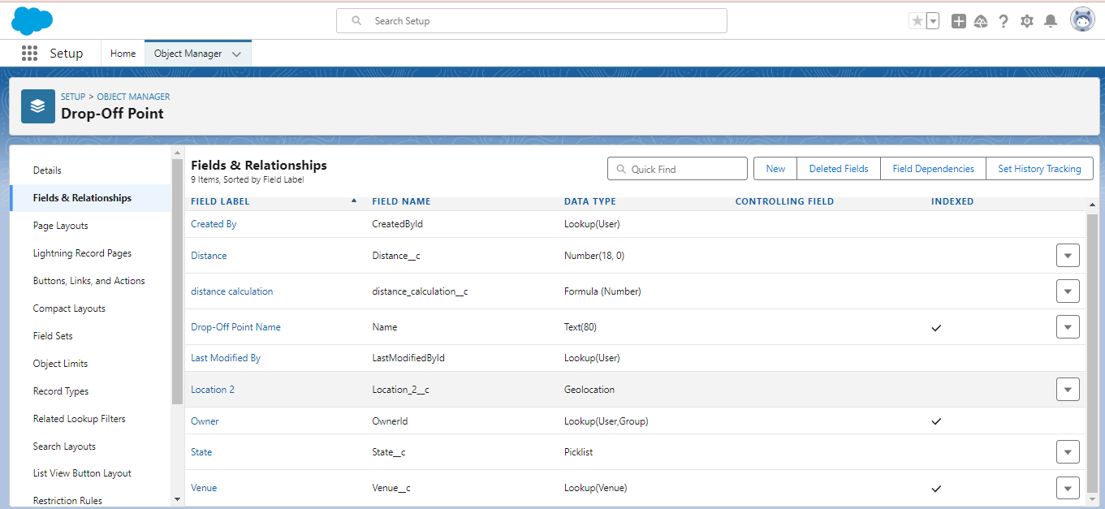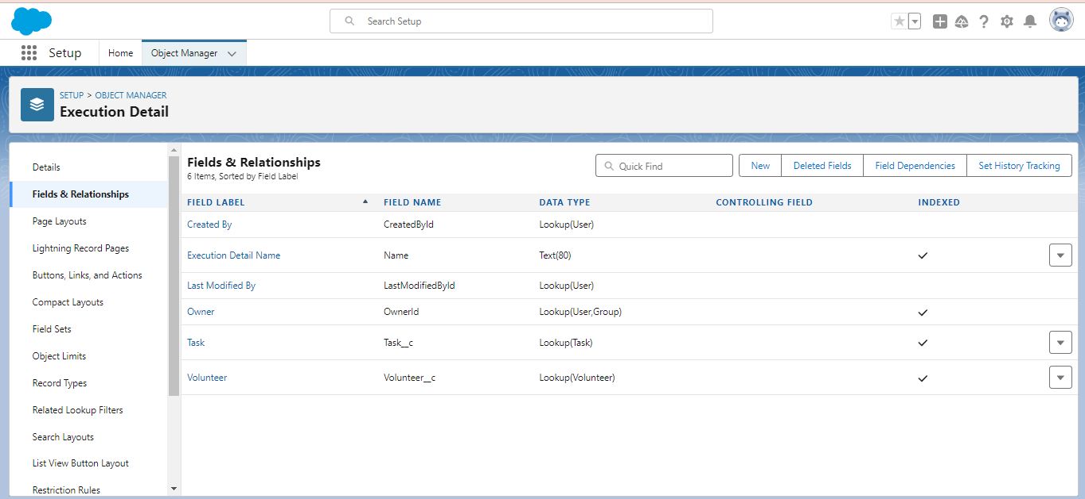

**FLOWS**

**Create Flow to create a record in Venue object**

1. Go to setup >> type Flow in quick find box >> Click on the Flow and Select the New Flow.
2. Select the Screen flow. Click on create.
3. Click on the ‘+’ icon in between start and end, and click on screen element.
4. Under the Screen Properties:

Label : Venue Details

API Name : Venue_Details

1. Now lets add components in this flow. Click on Text Component and name it as:

Label : Venue Name

API Name : Venue_Name

1. Click on Email Component and name it as:

Label : Email

API Name : Contact_Email

1. Click on Phone Component and name it as:

Label : Phone

API Name : Contact_Phone

1. Click on Text Component and name it as:

Label : Venue Location

API Name : Venue_Location

1. Click on Number Component and name it as:

Label : Latitude

API Name : Latitude

1. Click on Number Component and name it as:

Label : longitude

API Name : longitude

1. Next click on Done. This would like below
2. Click on the ‘+’ icon in between Venue details and end, and click on create record element.
3. Now label it as

Label : Create Venue Record

API Name : Create_Venue_Record

How Many Records to Create : One

How to Set the Record Fields : Use separate resources, and literal values

Object : Venue

Set Field Values for the Venue : Click on ‘Add Field’ 5 times

Field : Value = Contact_Email__c : {!Contact_Email.value}

Field : Value = Contact_Phone__c : {!Contact_Phone.value}

Field : Value = Name : {!Venue_Name}

Field : Value = Venue_Location__c : {!location}

Field : Value = Location__Latitude__s : {!latitude}

Field : Value = Location__Longitude__s : {!longitude}

1. This would look like:
2. Click on Save as:

Flow Label : Venue Form

Flow API Name : Venue_Form

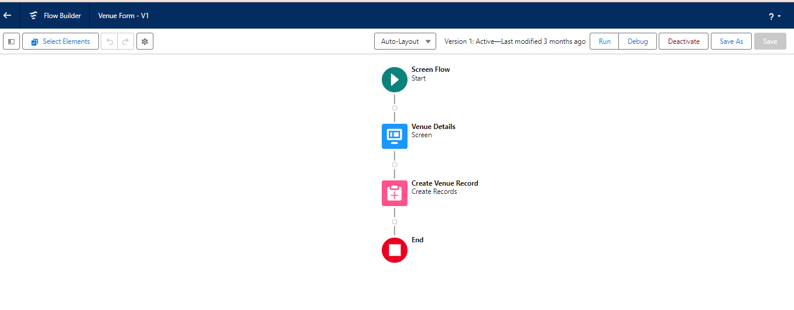

**TRIGGERS**

**Create a Trigger**

1. Log into the trailhead account, navigate to the gear icon in the top right corner.
2. Click on developer console and you will be navigated to a new console window.
3. Click on the File menu in the toolbar, and click on new >> Trigger.
4. Enter the trigger name and the object to be triggered.
5. Enter Name : DropOffTrigger

sObject: Drop-Off Point

1. Click on Submit.

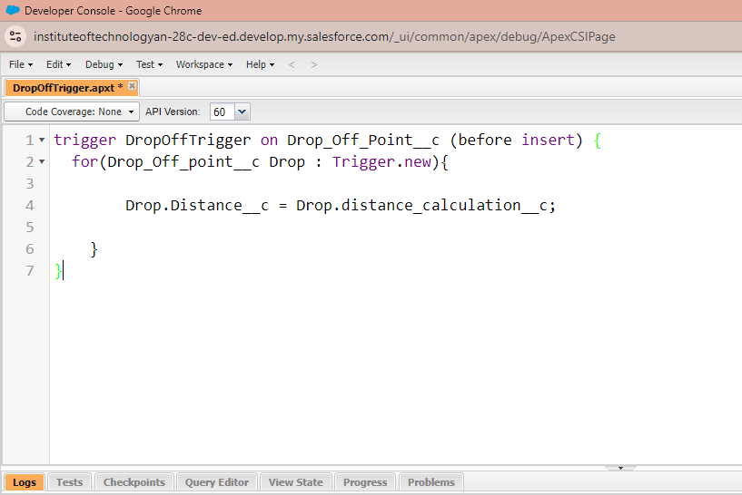

To create a matching rule to an Customer details Object

1. Go to quick find box in setup and search for matching Rule.
2. Click on matching rule >> click on New Rule.
3. Select the object as Customer details and click Next.
4. Give the Rule name : Matching customer details
5. Unique name : is auto populated
6. Define the matching criteria as
7. Field Matching Method
   1. Gmail Exact
   2. Phone Number Exact
8. Click save.

9.

After Saving Click on Activate.

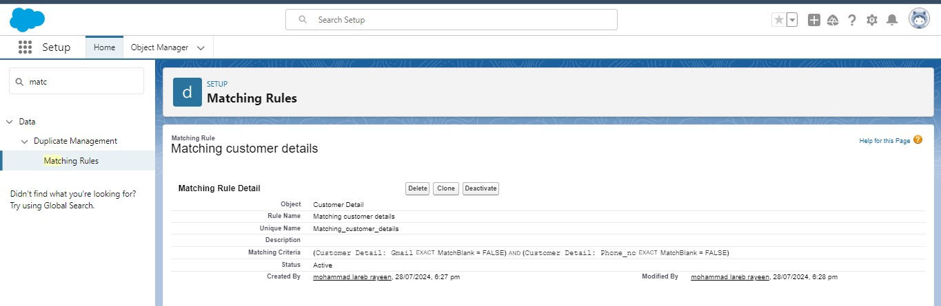

**PROFILES**

1. Go to setup page >> type Profiles in Quick Find bar >> click on Profiles >> click on ‘S’
2. Click on Clone beside Standard Platform User.
3. Under Clone Profile:

Profile Name : NGOs Profile

1. Then click on Save

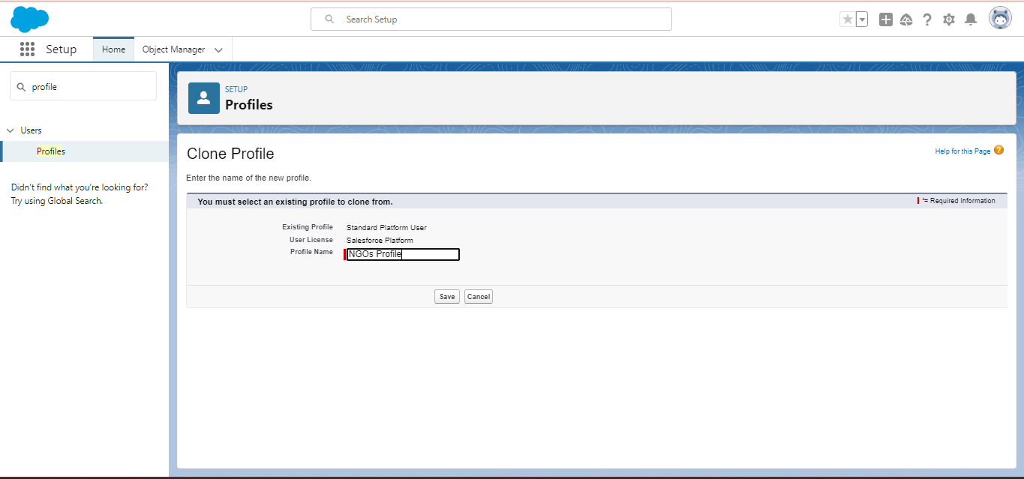

**CREATION OF USERS**

In our Project we consider them as NGO’s

**Creation of User1**

1. Go to setup page >> type users in Quick Find bar >> click on users>> New user.
2. In General Information give details as: (Note : create users as per your wish NGO’s)

First Name : Iksha Foundation

Last Name : Iksha_Foundation

Alias : iiksh

Email : Give Your Email

Username : [ikshafoundation@sb.com](mailto:ikshafoundation@sb.com) (give the username different)

Nickname : Auto Populated

User License : Salesforce Platform

Profile : NGOs Profile

Active : Check

1. Click on Save

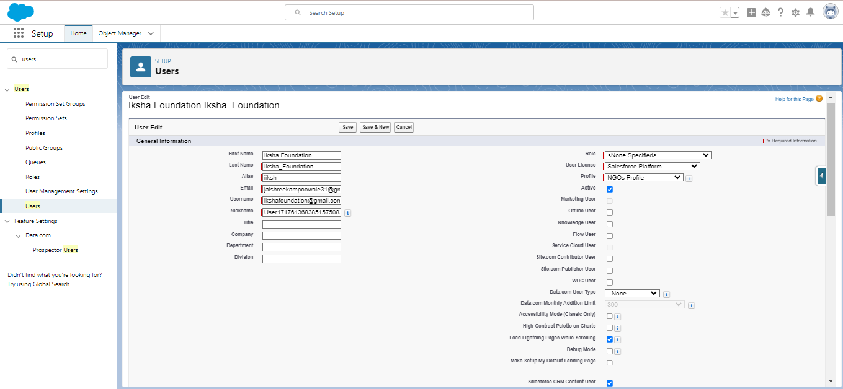

**Creation of User2, User3**

1. Create another Two Users by following steps in Activity - 1 with similar User License and Profile.
2. 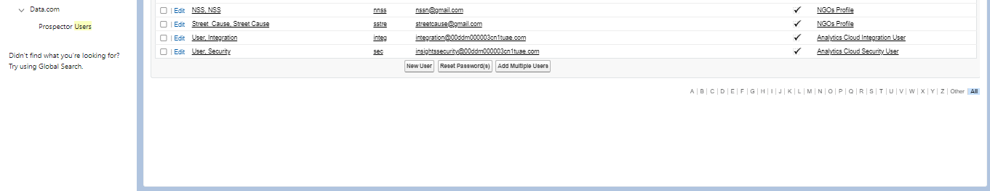Give Different First Name, Last Name based on Different NGO’s.

**PUBLIC GROUPS**

Creation of Public Group 1

1. Go to setup page  >>  type Public Groups in Quick Find bar  >>  click on Public Groups >>  click on New.
2. Under Group Information:

Label : Iksha

Group Name : Iksha

Grant Access Using Hierarchies : Check

1. In Search, Select Users.
2. In Selected Members Add Iksha Foundation and System Administrator

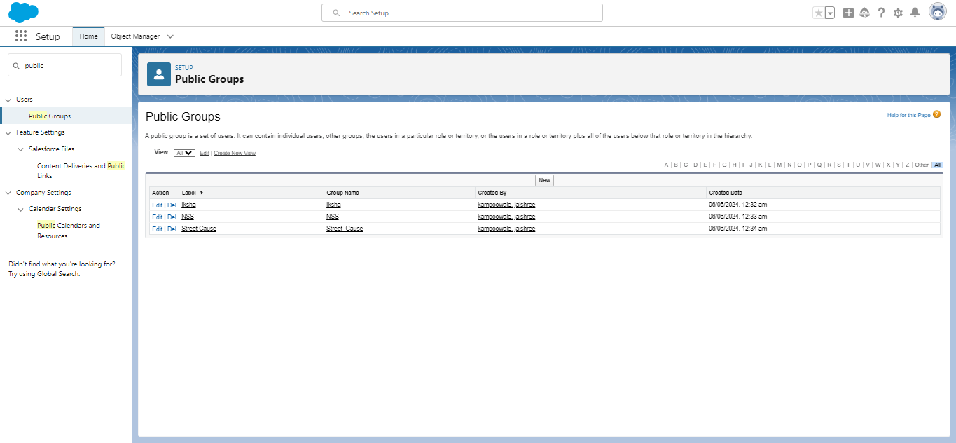

Creation of Public Group 2

1. By Following Steps in Activity 1, Create other  two Public Groups for other two users.
2. After Saving this would look like this.

**REPORT TYPES**

Creation of Report Types

1. Go to setup page  >>  type Report Types in Quick Find bar  >> click on Report Types  >>  click on Continue   >>  Click on New Custom Report Type.
2. In Define the Custom Report Type:

Primary Object : Select Venues

Report Type Label : Venue with DropOff with Volunteer

Report Type Name : Venue_with_DropOff_with_Volunteer

Description : Venue with DropOff with Volunteer

Store in Category : Select Other Reports

Deployment Status : Deployed

1. Click on Next
2. Near Click to relate another Object Select Drop-Off Points.
3. And also select "A" records may or may not have related "B" records.
4. Now again Near Click to relate another Object Select Volunteers.
5. Now click on Save

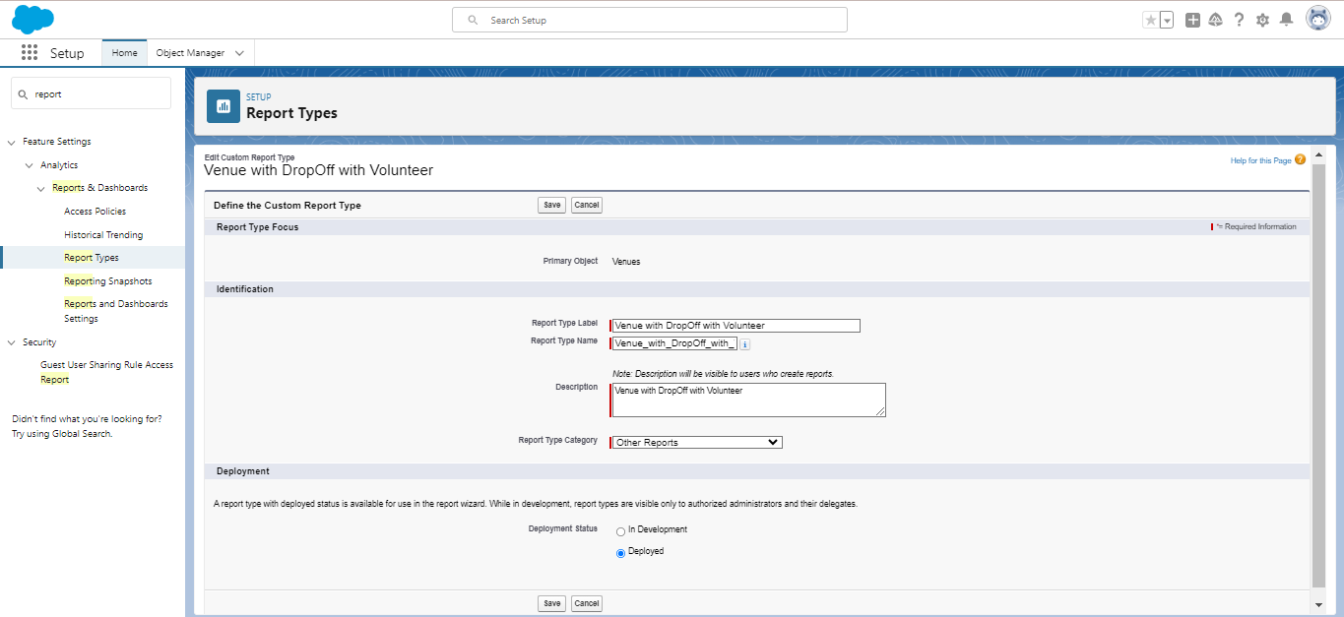

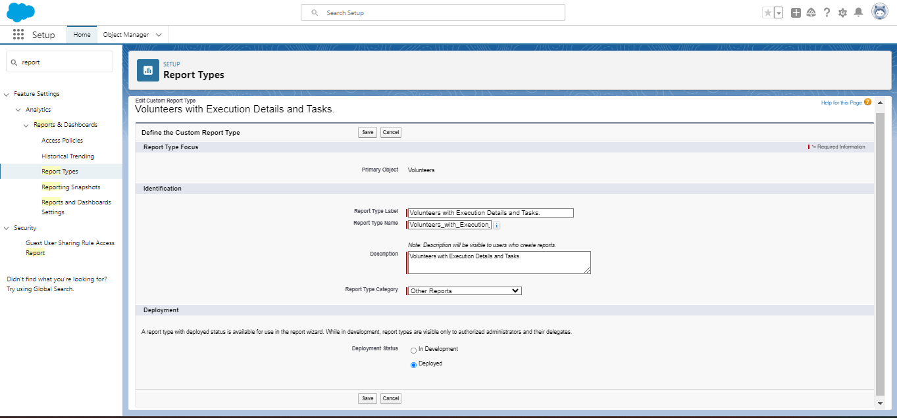

##### REPORTS

**Creation of Report on Venue with DropOff with Volunteer**

1. Go to the app(FoodConnect)  >>  click on the reports tab
2. Click on New Folder.

Folder Label : Custom Reports

Folder Unique Name : CustomReports

1. Open Custom Reports and click on New Report
2. Select Report Type : Venue with DropOff with Volunteer
3. Then click on Start Report.
4. In GROUP ROWS : Add Volunteer Name
5. In Columns : Add Venue Name, Drop-Off point Name, Distance.
6. Now click on Save & Run.
7. Give Label as :
8. Report Name : venue and Drop Off point
9. Report Unique Name : Auto Populated
10. Click on Select Folder and select Custom Report, then click on Save.

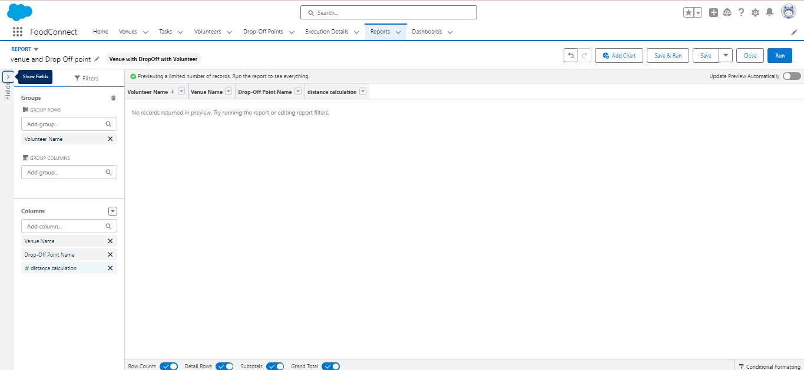

**Creation of Report on Volunteers with Execution Details and Tasks**

1. Go to the app(FoodConnect)  >>  click on the reports tab
2. Click on Custom Reports Folder and click on New Report
3. Select Report Type : Volunteers with Execution Details and Tasks.
4. Then click on Start Report.
5. In GROUP ROWS : Volunteer ID
6. In Columns : Add Volunteer : Volunteer Name, Task : Task Name, Execution Detail : Execution Detail Name, Volunteer: Owner Name, Task: Date, Task : Rating.
7. Now click on Save & Run.
8. Give Label as :

Report Name : Volunteer Task

Report Unique Name : Auto Populated

1. Click on Select Folder and select Custom Report, then click on Save.

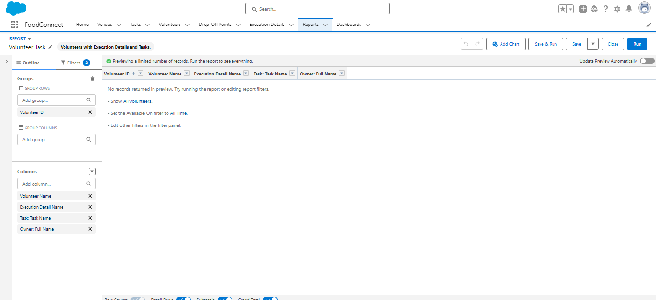

**DASHBOARDS**

Adding venue and Drop Off point Report to the Dashboard

1. Go to the app(FoodConnect)  >>  click on the Dashboards tab.
2. Click on New Folder.

Folder Label : Custom Dashboards

Folder Unique Name : Auto Populated

1. Open Custom Dashboards and click on New Dashboards
2. Name : Organization Details
3. Click on Widget and select Chart or Table
4. In Select Report : Select venue and Drop Off point Report.
5. Then click on select
6. In Add Component:

Display As : Select Lightning Table

Component Theme : Select Dark (Optional)

1. Now click on save.

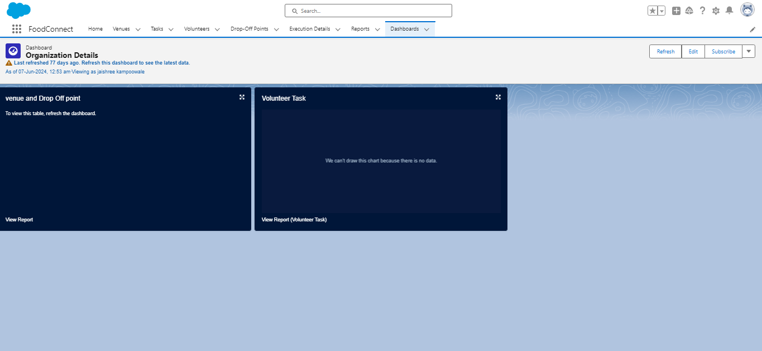

**SHARING RULES**

**Creation of sharing rules**

1. Go to setup  >>  type Sharing Settings in quick find box  >>  Click on the Sharing Settings.
2. Scroll down and find Drop-Off point Sharing Rules.
3. Click on new near Drop-Off point Sharing Rules and Name it as:

Label : Rule 1

Rule Name : Rule_1

1. Select your rule type : Select Based on criteria.
2. Select which records to be shared:

Field : Operator : Value = Distance : less than : 15

1. Select the users to share with : Near Share With

Public Groups : Iksha

1. Click on Save.
2. Click on new near Drop-Off point Sharing Rules and Name it as:

Label : Rule 2

Rule Name : Rule_2

1. Select your rule type : Select Based on criteria.
2. Select which records to be shared:

Field : Operator : Value = Distance : greater than : 15

Field : Operator : Value = Distance : less or equal : 30

1. Select the users to share with : Near Share With

Public Groups : NSS

1. Click on Save.
2. Click on new near Drop-Off point Sharing Rules and Name it as:

Label : Rule 3

Rule Name : Rule_3

1. Select your rule type : Select Based on criteria.
2. Select which records to be shared:

Field : Operator : Value = Distance : greater than : 30

Field : Operator : Value = Distance : less or equal : 50

1. Select the users to share with : Near Share With

Public Groups : Street Cause

1. Click on Save.

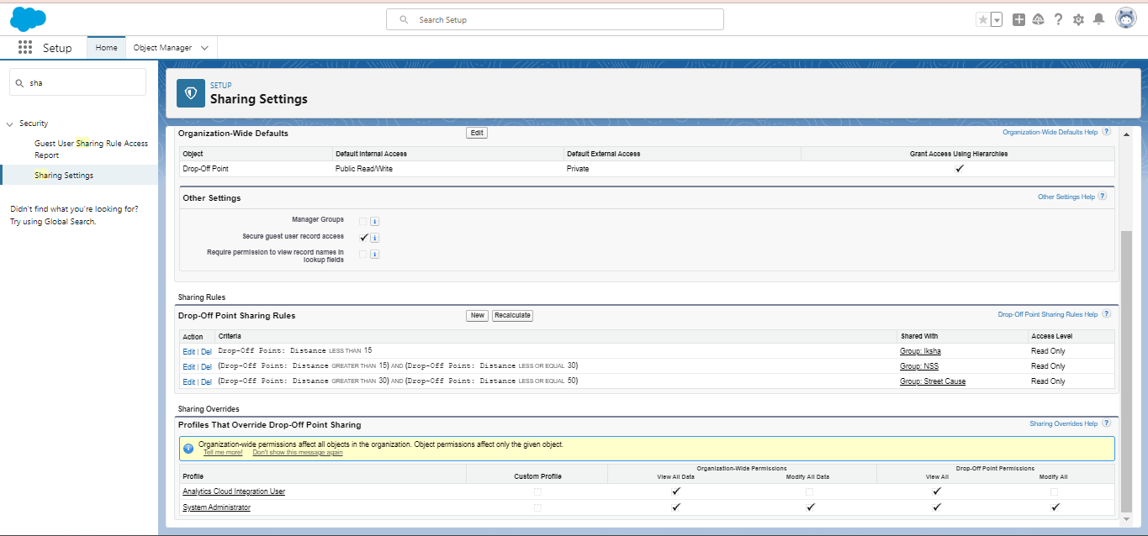

**HOME PAGE**

Creation of Home Page

1. Go to setup >> type Lightning App Builder in quick find box  >>  Click on the Lightning App Builder and Select the New.
2. Select Home Page and give Label as HOME Page.
3. Select Standard Home Page.
4. Near Components search for Flow and Drag and Drop in Right Side Section..
5. On the right hand side:

Flow : Venue Flow

1. Near Components search for Dashboard, then Drag and Drop it in first Section.
2. Click on Save and Activation, then click on App Default, then Add Assignments.
3. Add FoodConnect App and then Save.
4. FoodConnect Home Page would Look Like this.

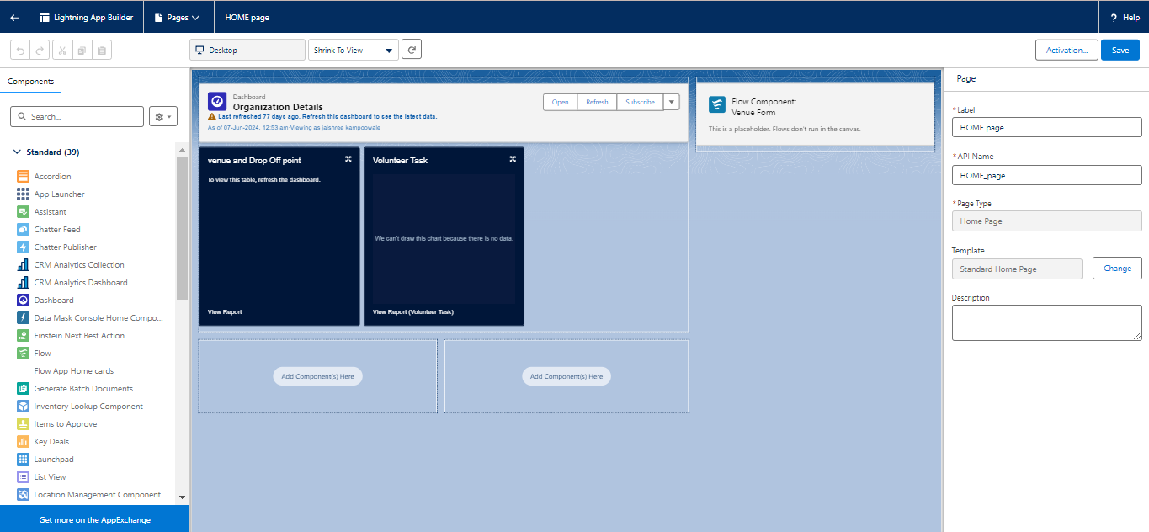

**CONCLUSION**

By leveraging the Salesforce platform, the project successfully established a streamlined and

transparent system for managing surplus food donations. Through efficient coordination with

volunteers and timely delivery to beneficiaries, the project effectively addressed food insecurity

while maximizing the utilization of available resources.